20th Annual
Hot Laps Mountain Bike Jam
Saturday, July 14th 2007
Snowbowl Ski and Summer Resort in Missoula, Montana
Hot Laps Mountain Bike Jam is part of the MORS mountain bike series and is an official USA Cycling event and will be conducted under USA Cycling competition rules.

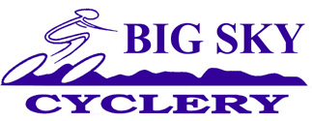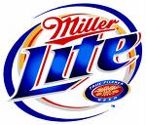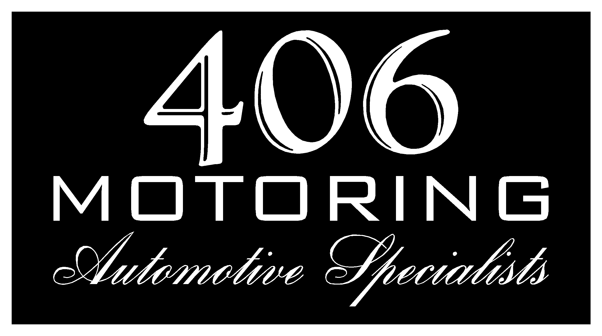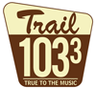

Call 543-3331 for more information or visit www.snowbowl.com
Downhill featuring Snowbowl’s Single Track Trail

9:00 am Registration: At the “Last Run”
10:00 am Load Grizzly Lift: All competitors will ride the Grizzly chairlift up and ride the single track “Beargrass Highway” to the event start- about half way down the trail.
10:30 am Individual Start: Competitors will start the course by classes. Finish will be at the base area across from the Last Run.
12:30 pm Awards Party: $400 guaranteed cash purse plus lots of prizes

Proper downhill personal protective equipment is required, i.e. helmet, eyewear, etc.
Call Big Sky Cyclery if unsure.

Entry fee: $25 (includes T-shirt, BBQ, NORBA insurance)
$5 Late Fee after 7/7/07.
-------------------------------------------------------------------------------------------------------------------------------
Registration Form
Register day of event at 9am or pre-register and avoid late entry fee of $5 by mailing this form and fee, postmarked by 7/7/07 or by bringing form and fee to
Big Sky Cyclery at 1110 South Ave., Missoula, MT 59801
Name (print):___________________________________________________________
Address: _______________________ City: ________________State:_____________
Phone: ________________________ Birthdate: ______________________________
Class: ____ Beginner ____ Sport ____Expert
Category: ____ Women ____Men ____Junior (18 & Under)
